(Approx. 670 words)

Microsoft Security Essentials
By Lynn Page, Editor, Crystal River User Group, Florida
www.crug.org
newsletter (at) crug.com

This article has been obtained from APCUG with the author’s permission for publication by APCUG member groups; all other uses require the permission of the author (see e-mail address above).
I have been using Windows Live OneCare for a couple of years on my laptop and have been very happy with it. OneCare is being discontinued next year and will not support Windows 7.
Microsoft Security Essentials is a real time security anti-malware application. The main difference between Microsoft Security Essentials and OneCare is that Security Essentials only provides malware protection while OneCare contains additional applications including a firewall, backup, tune up, multi pc management, simple Wi-Fi security configuration and simplified printer sharing.
With the upcoming discontinuation of OneCare, I loaded Microsoft Security Essentials, a free download from Microsoft, on my desktop to try it out. I still run a personal firewall and left one other anti-malware application on the computer. Security Essentials is designed to provide real-time anti-malware protection from threats including viruses, spyware, rootkits, Trojans, and other emerging threats in a single application.
The download of Microsoft Security Essentials is free and installation simple. The program is easy to use. As it does everything in the background. Automatic updates assure that your computer is protected by the latest available technology. Like OneCare Security Essentials makes it easy to see if the computer is secure. The green icon means it’s secure.
The Installation Wizard walks you through the installation which only took a few minutes. Its first step requires validation of your copy of Windows. Then you are instructed to remove any other antivirus or antispyware applications installed on the computer. There is even a link to tell you how to remove the applications. Based on Alfred’s discussion at the October meeting I expected this and had already uninstalled my antivirus application. Since the anti-malware program I have installed does not run in the background I left it on the computer.
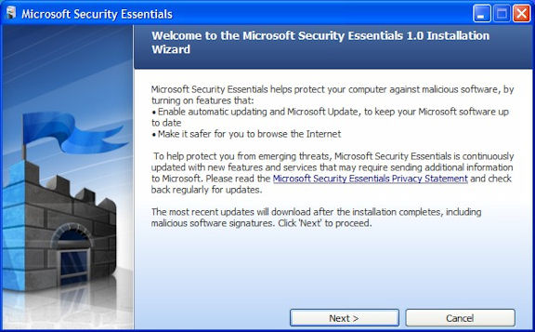
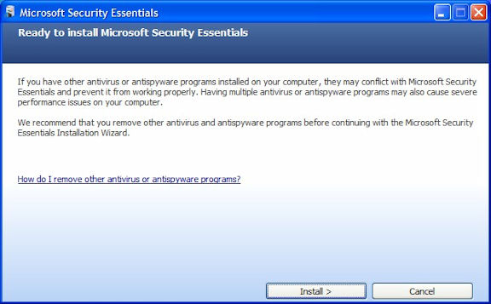
Microsoft Security Essentials runs efficiently in the background so you can use your computer without interruptions or long wait times. When completing the installation The Wizard you have the opportunity to request a scan of your computer.
When finished Microsoft Security Essentials starts and automatically checks for updates before running the requested scan. Since it is new application you will have to instruct your firewall to allow it to connect to the internet.
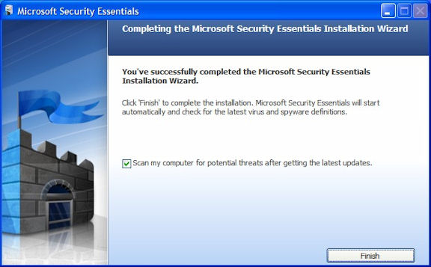
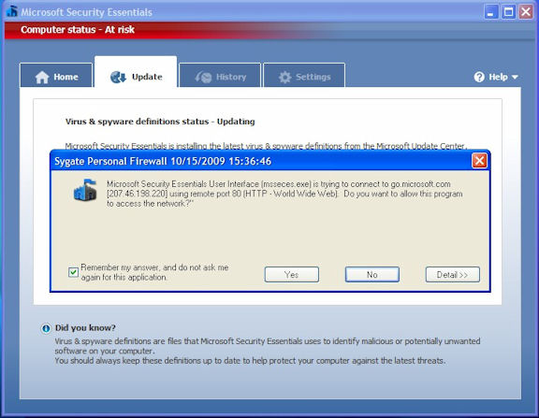
Until the updates and initial scan are computer Security Essentials shows the red warning that your computer is at risk. Once the scan is complete and any problems addressed the computer status will be green or Protected.
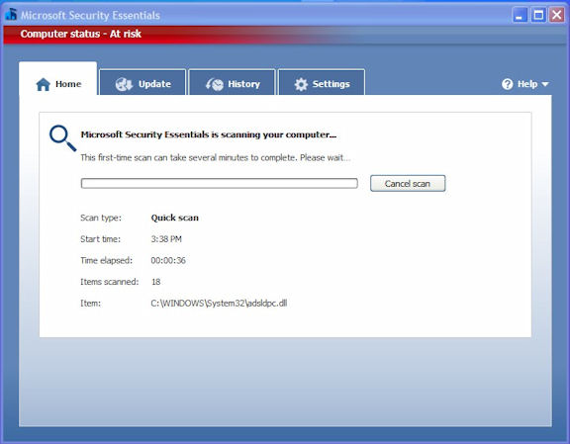
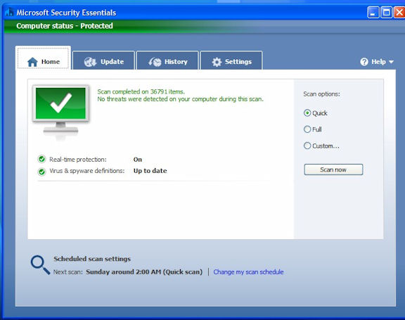
The Security Essentials interface is tab based. The Home tab displays the application’s status. Note that Real-time protection is on and definitions are up to date. Security Essentials performs scheduled scans but you can select and run a manual scan from the Home tab. When running a System Scan, select from Quick, Full, or Custom. I ran both a quick scan and then a full scan on my computer. If a threat is detected Security Essentials changes to show the computer is at risk and that a threat has been detected. To remove a threat click the Clean computer button displayed on the Home tab.

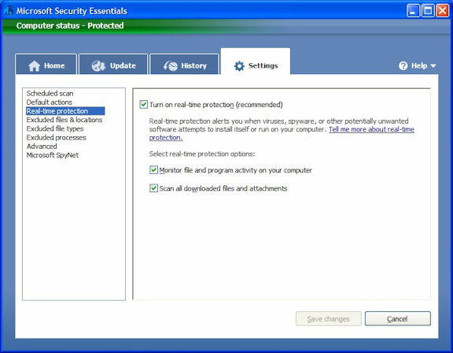
The Settings tab provides control over the application. I saw no reason to make any changes from the default settings. The one thing you might want to change is the scan schedule. You can schedule a scan by clicking the Change My Scan Schedule link on the Home window or on the Settings tab.
The History tab displays all Detected Items, Quarantined Items, and Allowed Items. Remove the history by clicking the Delete History button.
I haven’t been running Microsoft Security Essentials long but my experience with OneCare tells me it will work well and protect my computer from threats. I have already noticed that the computer runs faster during scans than with my previous software.

